**FTP File Sync Service User Guide**

Contents

1 Document History 1

2 What is the FileSync Service 1

3 Configuring FileSync 1

4 File Sync Logging and Monitoring 2

5 What Happens when Errors Occur 3

6 Causes of Fatal Errors and Connection Retry Logic 4

# Document History

The master version of this document is stored by TfL in the FTP TFS Source Control at; $/Deployment/Main/Documents.

Any version of this document not from this location is not controlled.

|  |  |  |  |
| --- | --- | --- | --- |
| **Date** | **Version** | **Changes** | **Changed By** |
| 01/09/2013 | 0.1 | First Draft | Hamad Shather |

# What is the FileSync Service

The File Sync is a windows service that sits on the FTP internal domain. It manages the transfer of files from one location to another and supports SFTP as well as standard Windows file access protocols.

In the case of FTP files are transferred from the FTP PARE server to Cubic and vice versa and connection to Cubic is done via SFTP.

# Configuring FileSync

The File Sync service is fully configurable via the app.config file. Each movement of files from one place to another is called a **transfer** and the file sync service can support an unlimited amount of transfers. Each transfer operates completely independently of other transfers.

To set up a transfer we need to specify a source and target location (either windows or SFTP), connection data plus a specify a few options.

<fileTransferSettings>

   <fileTransfers>

     <add name="TapFile" fileFilter="*.csv" maxDOP="3" bufferSize="64"

maxRetries="5" pollDelay="3000">

     <sourceFileSystem type="SFTP" URL="sftp://emvsftp@172.30.211.14:22/outbound">

        <options>

           <add name="password" value="password" />

           <add name="authenticationtype" value="UserPassword" />

        </options>

     </sourceFileSystem>

  <targetFileSystem type="Windows"

URL="file://\\FPDC2PAI001\d$\TapFileProcessor\Unprocessed" />

    </add>

<fileTransferSettings>

The above sets up a transfer of .csv files from the 'outbound' folder on SFTP server 172.30.211.14 (user emvsftp) to \\FPDC2PAI001\d$\TapFileProcessor\Unprocessed.

**fileFilter:** filter what files are transfered. Use *.* to transfer all files.

**maxDOP:** The max number of files filesync will try to transfer in parallel for this transfer

**bufferSize:** The buffer transfer size (kilobytes)

**maxRetries:** The max number of times file sync will try to transfer a file. If this number is exceeded, the file is moved to a 'FAILED' folder

**pollDelay:** The time (milliseconds) between polls of the source file system. Used to throttle the polling

In addition to configuring the transfer, a log4net logger should also be configured to do transfer level logging.

# File Sync Logging and Monitoring

Logging happens at two levels. At the service level logs are written under a custom event log on the FTM server.

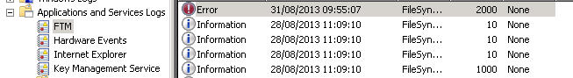

Transfer level logs, containing info like what files are been transferred and when, are written to .log files at d:\tfl\FTM\FileSync\logs on the FTM server. One log file for each transfer.

# 

# What Happens when Errors Occur

If a file has failed transfer more than the allowed number of times it will be copied to a folder named 'FAILED' at the source location. This is the first place you should check to see if any files have not gone through.

If any transfer suffers what we call a **fatal error**, an error from which it cannot recover, then the file sync service shuts that transfer down. The service stays up and all other transfers continue to operate. This is to ensure an error in one transfer doesn't bring down the whole operation.

When such a fatal error like this occurs a 'fatal' event is written to the FTM event log. Fatal events have event id **2000** and so can easily be identified

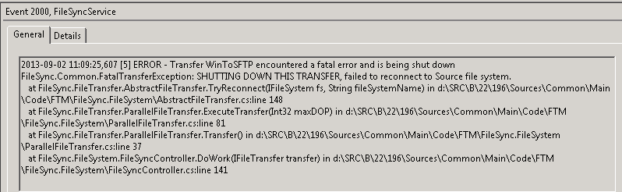

A fatal event should be monitored for in the event log and such an event tells us part of the file sync system has stopped working and needs to be fixed.

Once the cause of this fatal error has been diagnosed and fixed we need to restart the problem transfer. This can only be done by restarting the whole service. If the service starts successfully then all transfers are up and running. Service starts are logged in the event log with event id **1000**, in this way we can tell if a fatal error has been resolved by looking for a a succesful restart coming after.

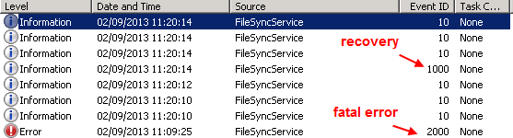

# 

# Causes of Fatal Errors and Connection Retry Logic

Most fatal errors when a transfer cannot connect to it's source or target location. In order to prevent small blips in connectivity bringing down the whole service file sync transfers use connection retry logic to try and reconnect to their source or target. The settings are in the appSettings of the service config file.

  <appSettings>

    <add key="ConnectionRetryLimit" value="6"/>

    <add key="ConnectionRetryWaitTime" value ="15"/> <!--seconds-->

  </appSettings>

Here we can see if a filesync transfer loses connection to either its source or target then it will try to reconnect a maximum of 6 times with a 15 second in between each try. If it successfully reconnects all just continues as usual. If it cannot reconnect then a fatal error is logged and the transfer is question is shut down. The connection retry logic can be seen in the transfer .log files

*2013-09-02 11:07:55,544 [5] ERROR - We are no longer connected to the source, trying to reconnect*

*2013-09-02 11:07:55,544 [5] INFO - Attempting to reconnect to the Source. Try number: 1*

*2013-09-02 11:07:55,575 [5] ERROR - Failed to reconnect to Source file system*

*System.ApplicationException: Cannot connect to \\TS-WIN1\d$\tfl\ftm\sourcefiles*

*at FileSync.FileSystem.WindowsFileSystem.Connect() in d:\SRC\B\22\196\Sources\Common\Main\Code\FTM\FileSync.FileSystem.Windows\WindowsFileSystem.cs:line 42*

*at FileSync.FileTransfer.AbstractFileTransfer.<>c__DisplayClass1.<TryReconnect>b__0() in d:\SRC\B\22\196\Sources\Common\Main\Code\FTM\FileSync.FileSystem\AbstractFileTransfer.cs:line 128*

*2013-09-02 11:08:10,606 [5] INFO - Attempting to reconnect to the Source. Try number: 2*

*2013-09-02 11:08:10,606 [5] ERROR - Failed to reconnect to Source file system*

*System.ApplicationException: Cannot connect to \\TS-WIN1\d$\tfl\ftm\sourcefiles*

*at FileSync.FileSystem.WindowsFileSystem.Connect() in d:\SRC\B\22\196\Sources\Common\Main\Code\FTM\FileSync.FileSystem.Windows\WindowsFileSystem.cs:line 42*

*at FileSync.FileTransfer.AbstractFileTransfer.<>c__DisplayClass1.<TryReconnect>b__0() in d:\SRC\B\22\196\Sources\Common\Main\Code\FTM\FileSync.FileSystem\AbstractFileTransfer.cs:line 128*